First Web Api using .Net core

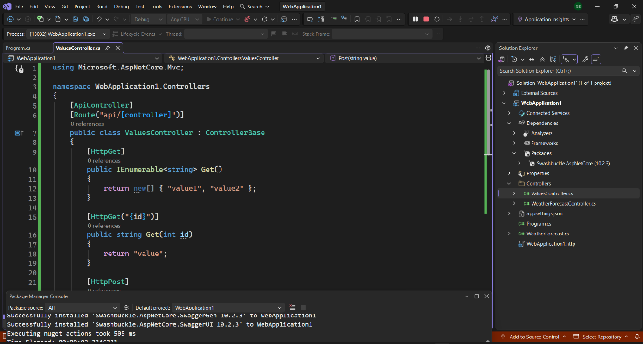
After selecting controller with read/write operations

ValueController.cs

using Microsoft.AspNetCore.Mvc;
namespace WebApplication1.Controllers
{
[ApiController]
[Route("api/[controller]")]
public class ValuesController : ControllerBase
{
[HttpGet]
public IEnumerable<string> Get()
{
return new[] { "value1", "value2" };
}
[HttpGet("{id}")]
public string Get(int id)
{
return "value";
}
[HttpPost]
public IActionResult Post([FromBody] string value)
{
return Ok("Added " + value);
}
[HttpPut("{id}")]
public IActionResult Put(int id, [FromBody] string value)
{
return Ok($"Updated {id} with {value}");
}

[HttpDelete("{id}")]
public IActionResult Delete(int id)
{
return Ok($"Deleted {id}");
}
}
}

Checking if API is running or not
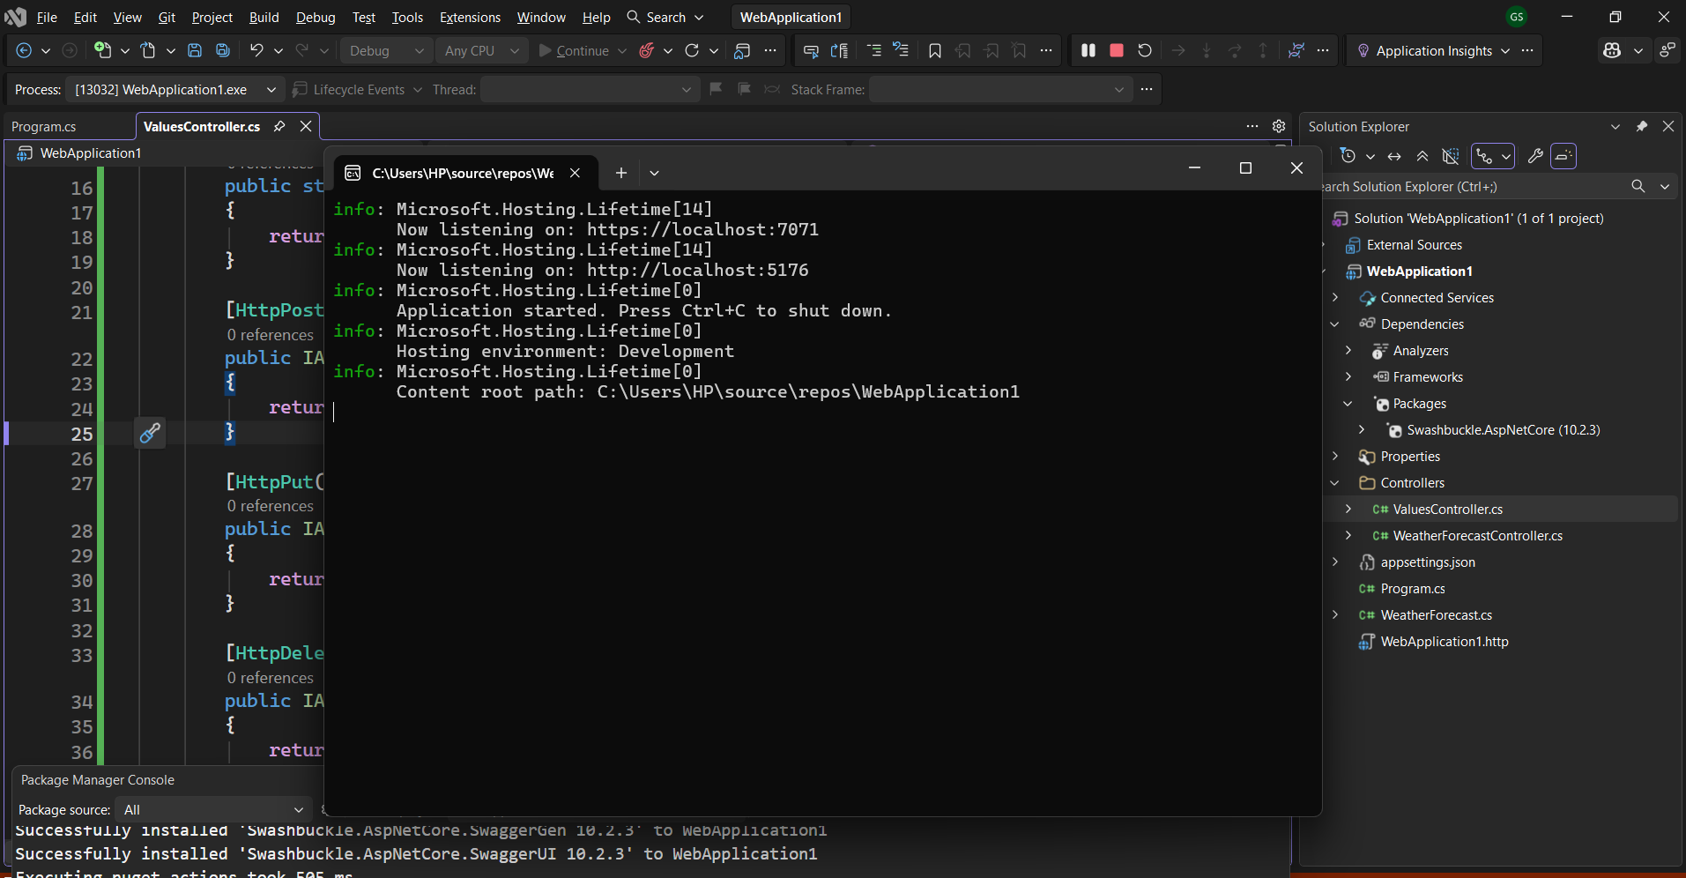

Accessing API URL
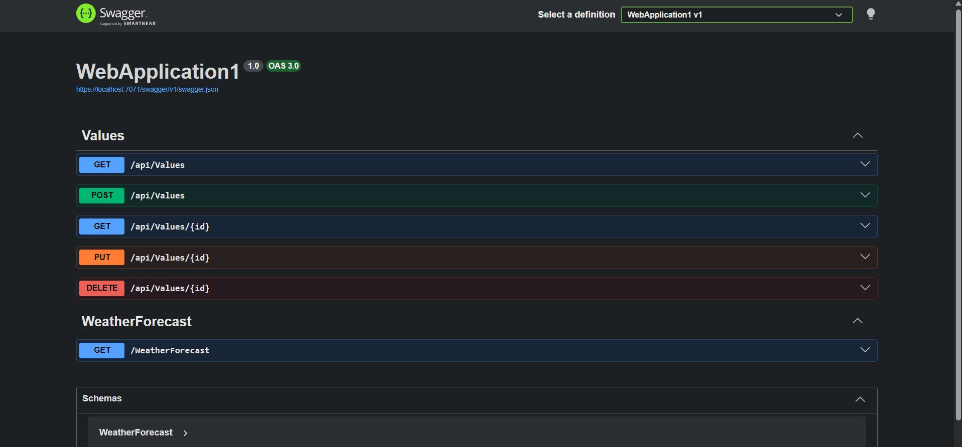

Trying out GET req using Swagger
